**User Guide**

**SEE**



USER GUIDE - SEE

*Modern Statistics Platform*

**Revision History**

|  |  |  |  |
| --- | --- | --- | --- |
| Name | Date | Reasons of Changes | Version |
| iTM | 08th December 2023 | The first draft of SEE MauStats. | V1 |
| iTM | 17th June 2024 | The second draft of SEE MauStats. | V2 |

Table of Contents

1.0 INTRODUCTION 4

2.0 SEE 5

2.1 SURVEY QUESTIONNAIRE 6

**2.1.1** **Setup** 7

**2.1.2** **Question** 8

**2.1.3** **Calculate** 11

2.2 SURVEY MANAGER 14

**2.2.1** **Pending** 14

**2.2.2** **In progress** 21

**2.2.3** **Completed** 25

**2.2.4** **Calculated** 28

**2.2.5** **Validated** 30

**2.2.6** **Cancelled** 32

# 1.0 INTRODUCTION

The Modern Statistics (MauStats) Platform is developed as a web-based platform with a central database to ensure consistency, security and accessibility. The platform is used to help to automate and integrate data lifecycle from acquisition to dissemination using Generic Statistical Business Process Model (GSBPM) framework. The platform complies to manage data requirements for Census, SEE, and SBR processed data in this phase. It is also feasible for data integration based on SM requirements. This web-based platform consists of the two applications – User Interface and Data Management System (DMS).

In this user guide, we will be learning on how to use the SEE module of the DMS application.

# 2.0 SEE

The SEE module comprises two submodules which allows management and administration of survey questionnaires and surveys. Below are the sub-modules of the SEE–

* Survey Questionnaire
* Survey Manager

Let us learn how to use these sub-modules in detail.

## 2.1 SURVEY QUESTIONNAIRE

This submodule allows the authorized users to create and manage the survey questionnaires.

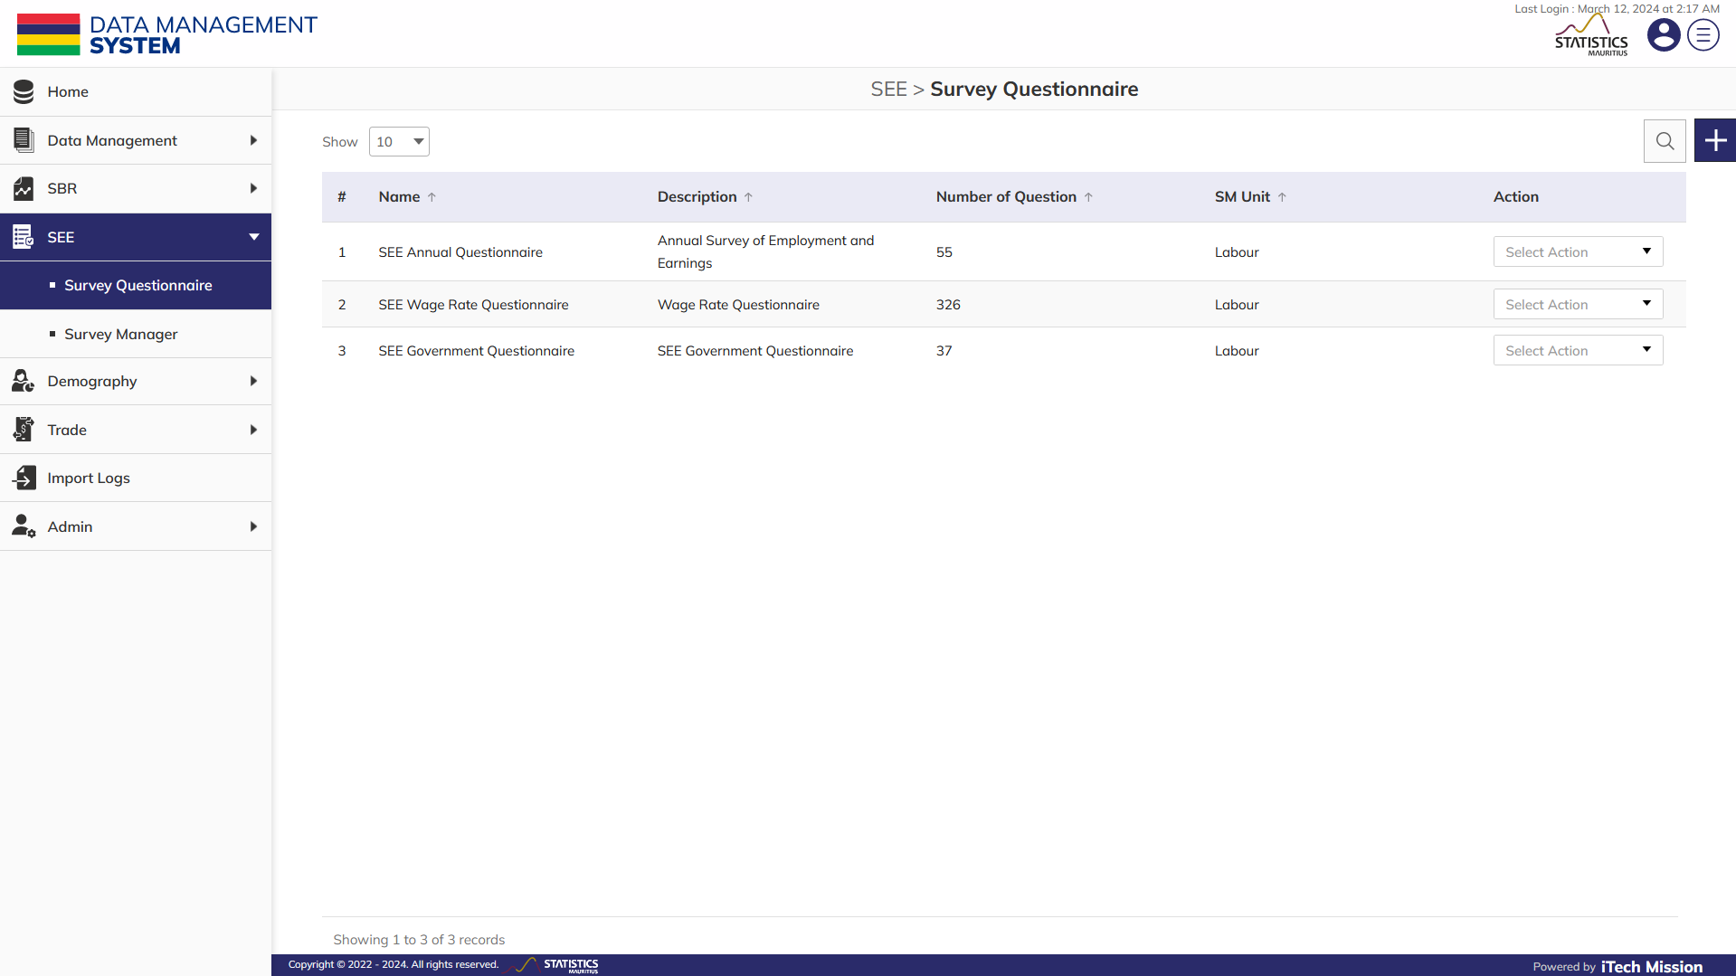**Step 1:** Click on the **Survey Questionnaire** option available under SEE to access this sub-module. You have the options to add, edit, delete and copy questionnaire (see below figure)

### **2.1.1 Setup**

**Step 2:** Click on the Plus button available to the right side of the page to add a new questionnaire (see figure below).

The Add Survey Questionnaire form is divided into sections namely – Setup, Question and Calculate. Navigate from one section to another using the **Next** and **Previous** button available in each section.

**Step 3**: First section is “**Setup”**. Enter the following details:

* Enter **SM Unit**
* Enter **Survey Questionnaire Name**
* 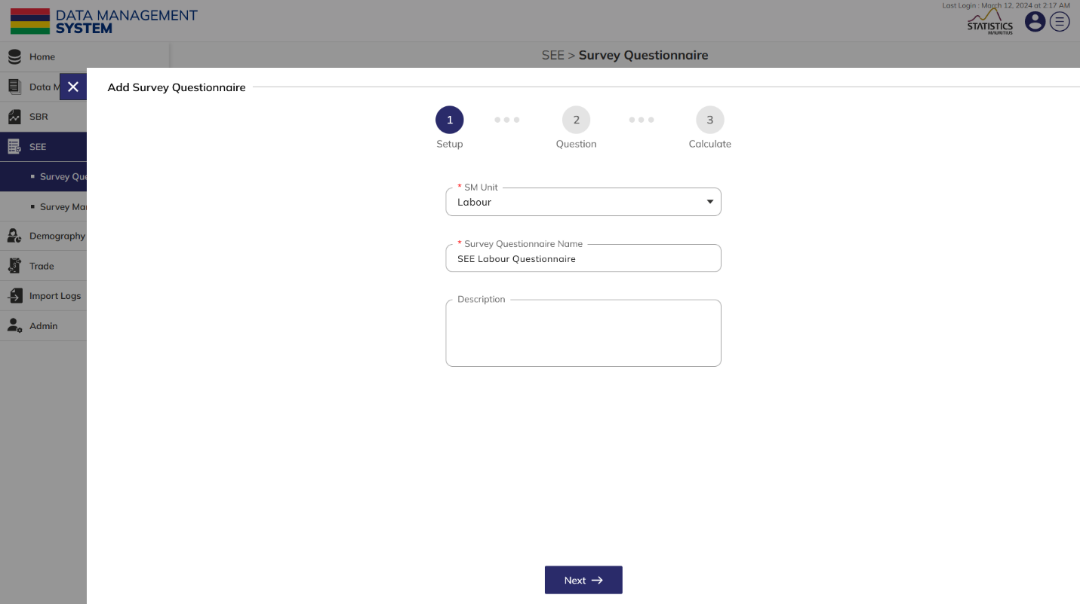Enter **Description**

All details that are mandatory to be entered.Click on the **Next** button to save and move to next section.

### **2.1.2 Question**

**Step 4**: Second section is **“Question”.** This section allows the authorized users to create and manage the survey questions. You have the options to view, edit, delete and copy a question from the existing list of questions and add a new question to the list.

**Step 5**: Click on the **Plus** button available to the right side of the form to **add** a new question. Enter the following Details.

* 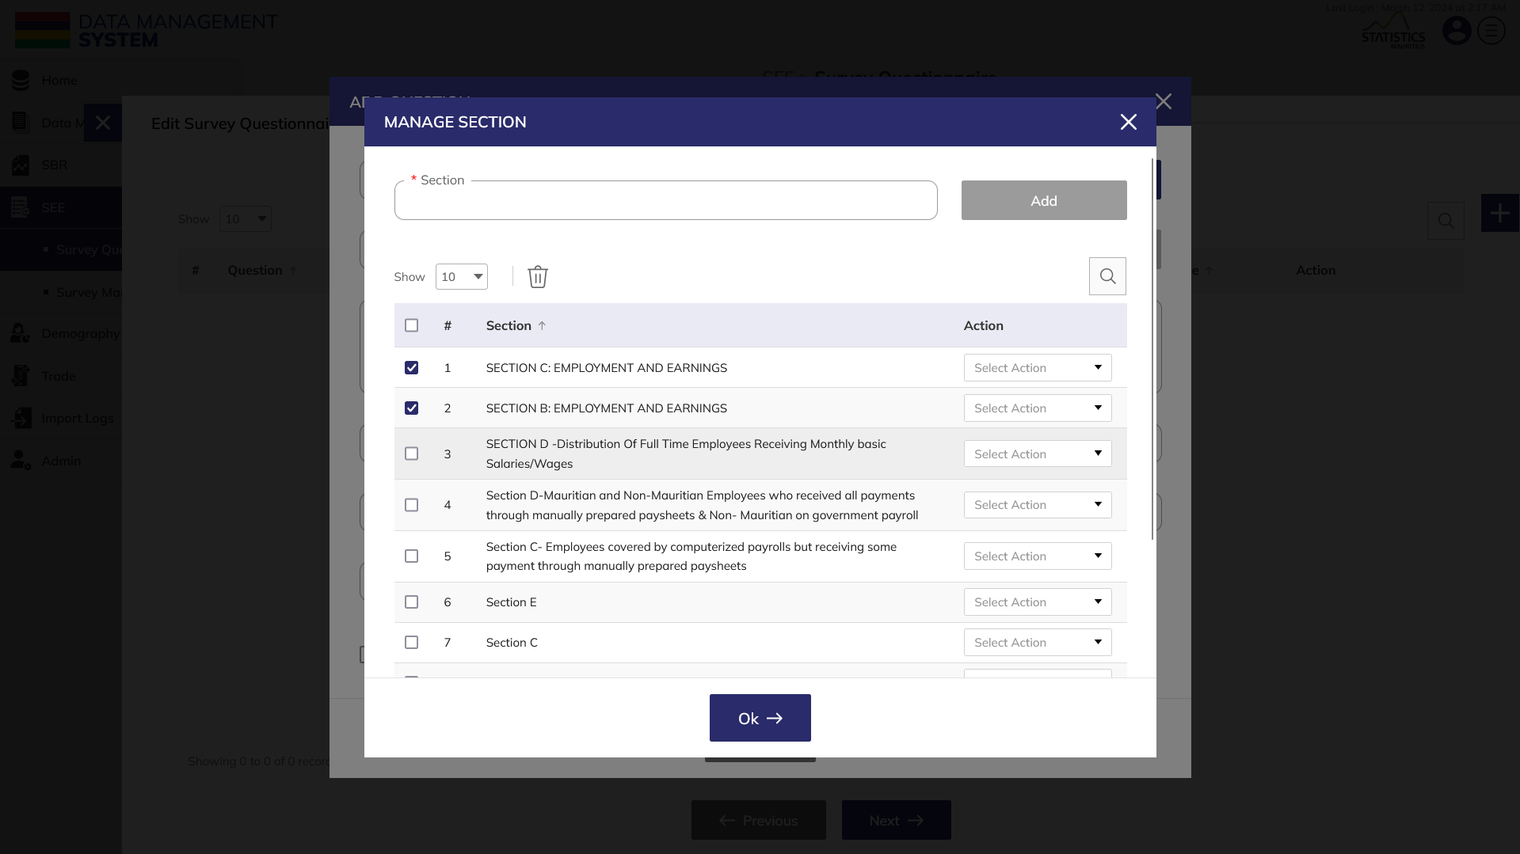Select **Section** through **Manage section** button and **Subsection** through **Manage Subsection** button. Click on **Ok** to save these options.

**NOTE:**

If you want to add a new section which is not present in the options, then add the section name in the textbox that is present at the top and then click on Add option. User can select more than one section by selecting the required checkbox.

Same procedure is applicable in Subsection as well.

* Select **Section** and **Subsection** from the list that is selected using the previous step.
* Enter **Question Text**.
* Enter **Alias.**
* Enter **Hint**.
* Select **Type** of the Question (*Textbox, Numeric, Date, Single Choice, Multi Choice, Grid)***.**

*In case of* ***Numeric*** *type –*

* Enter **Minimum**, **Maximum**, **Default** Value and **Decimal places.**

*In case of* ***Date*** *type –*

* Select **Date Format**

*In case of* ***Single choice/Multi-choice*** *type –*

* Manage and Select **Options**
* 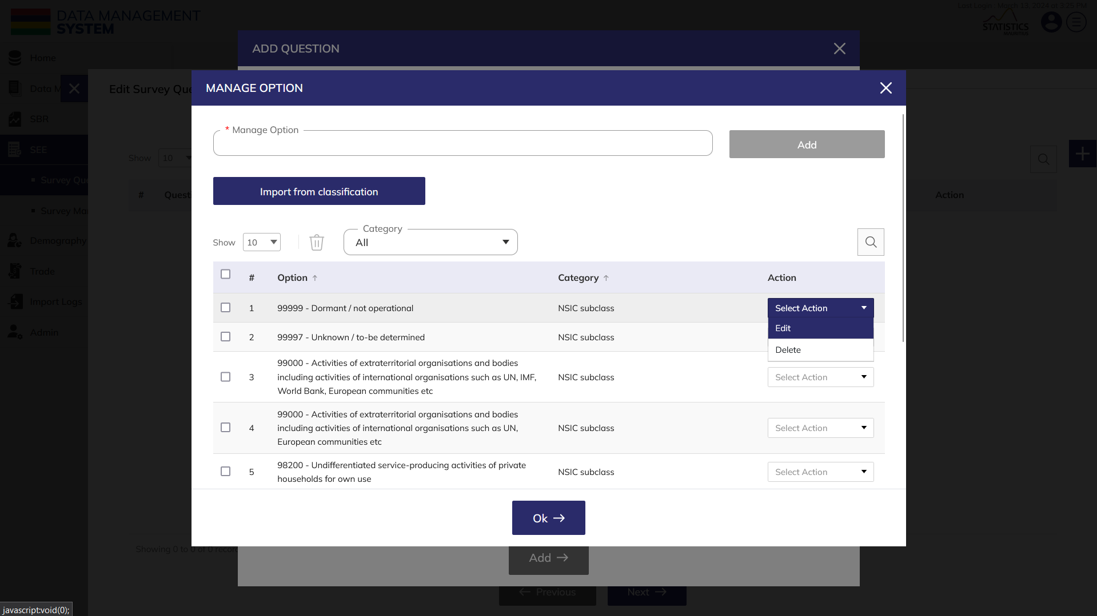After clicking on manage options, select the **Category** and then select the options. You can edit and delete the options.

*In case of* ***Grid*** *type –*

**NOTE:**

If you want to add a new option which is not available in the list, then enter the option in the textbox present at the top and click on Add option. You can import options from classification as well.

* Select number of **Columns**, click on the arrow near it and add the header for these columns.
* Select number of **Rows**, click on the arrow near it and add the header for these rows.
* Click on the arrow present to add the value in the grid. Select the type of the entry and add the data.
* Select the **Mandatory** checkbox if required.
* Select the **Non Editable** checkbox if required.

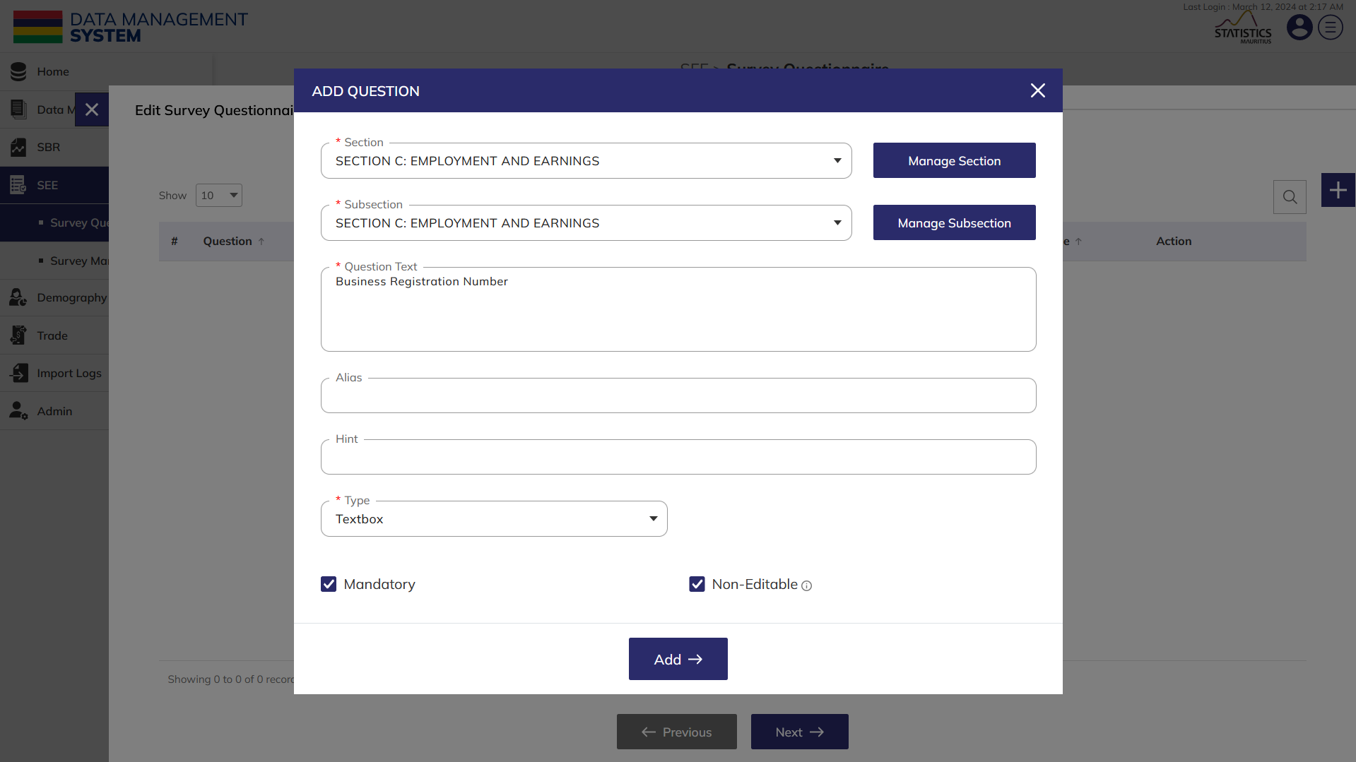**Step 6**: Click on **Add** button to add the question in the form.

All details that are mandatory to be entered.Click on the **Next** button to save and move to next section.

### **2.1.3 Calculate**

**Step 7**: Third section is **“Calculate”.** This section allows the authorized users to create and manage the calculations in the survey. You have the options to view, edit and delete a calculation formula from the existing list of calculations and add a new calculation to the list.

**NOTE:**

This step can be skipped if no calculation is required. Calculation can only be applied to questions with numeric and grid datatype.

**Step 8**: Click on the **Plus** button available to the right side of the form to **add** a new calculation. Enter the following details.

* Enter the **Description**.
* Select the **question 2** from question list.
* Select the operator **“+”** from the available operators.
* Now select the **question 3**.

**Step 9**: Click on the “**Validate”** button to check whether the created expression is arithmetically correct.

**Step 10:** After the expression is validated, click on the **Ok** button to confirm.

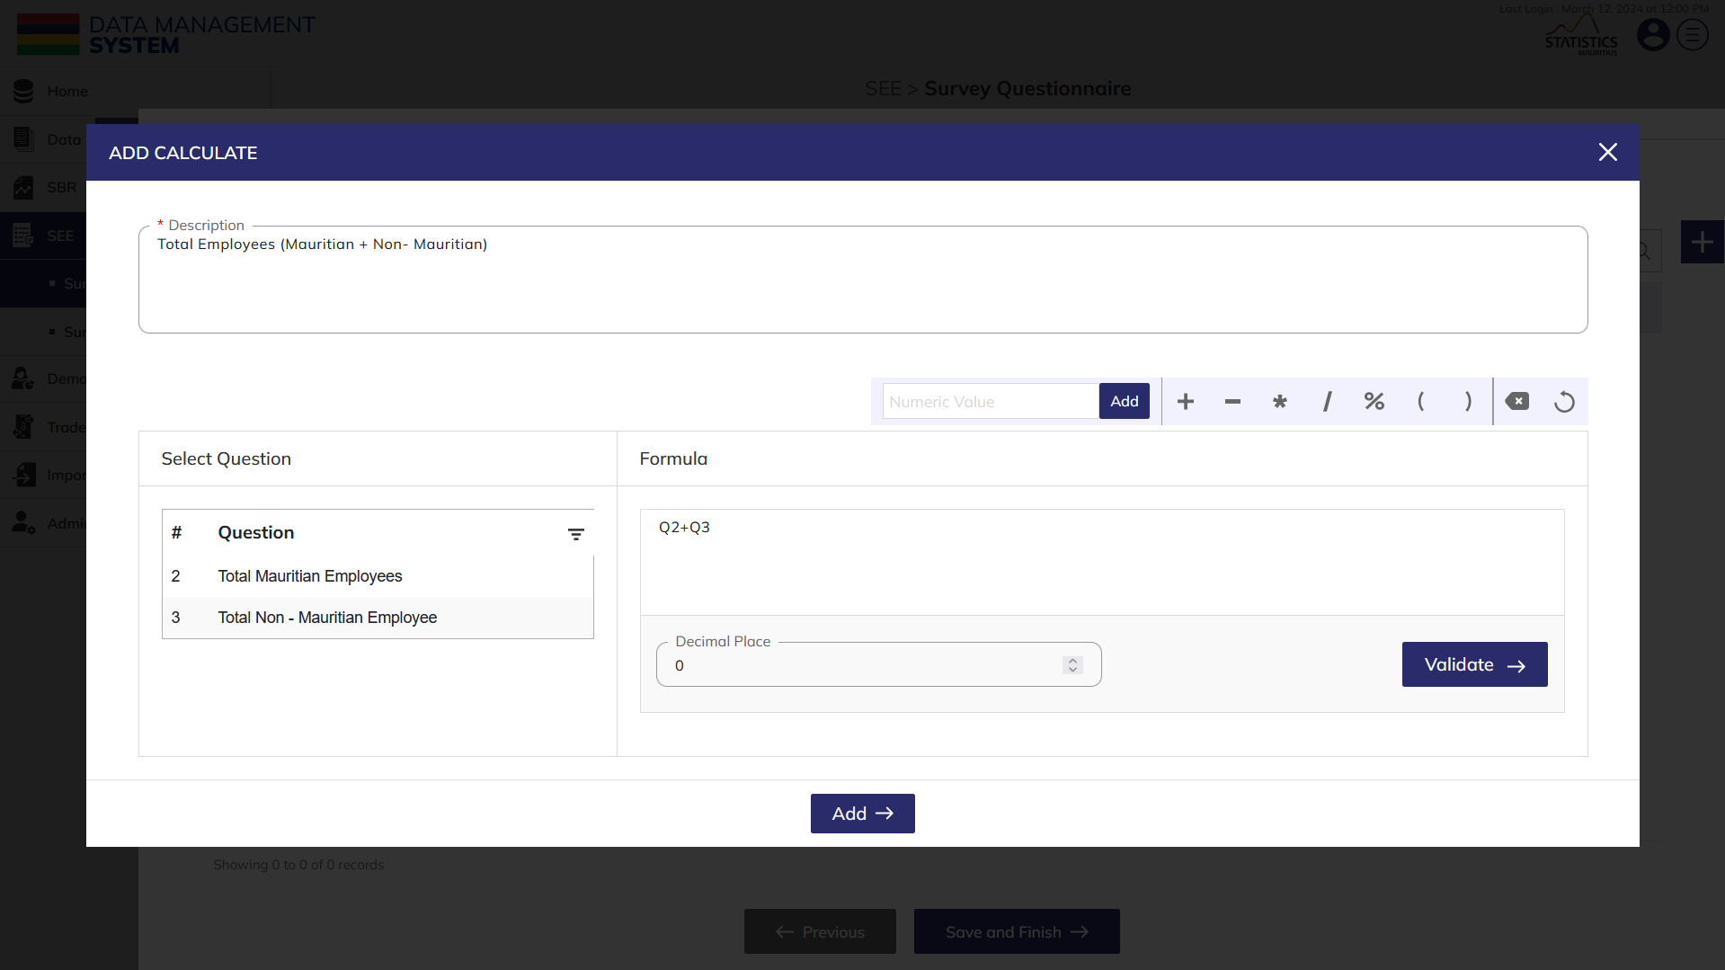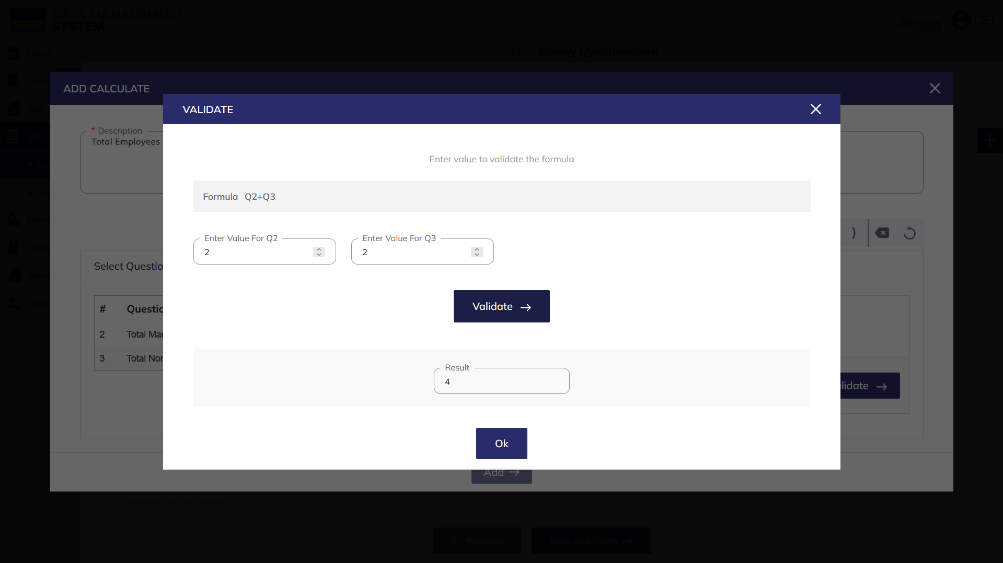**Step 11:** Click on the “**Add**” button to create the calculation.

All details that are mandatory to be entered.Click on the **Save and Finish** button to save and add the questionnaire.

**Step 12**: Click to select **Edit** option available in the action dropdown to edit the details of the selected element. Edit the required detail and click on update button to save and confirm.

**Step 13**: Click to select **Delete** option available in the action dropdown to delete the selected element. A confirmation popup will appear, click yes to confirm deletion of selected element.

**Step 14**: Click to select **Copy** option available in the action dropdown to copy the questionnaire.

## 2.2 SURVEY MANAGER

Click on the **Survey Manager** option available under SEE to access this module. This module allows you to manage data collection of Survey Questionnaires. This module has six tabs in this module namely Pending, In Progress, Completed, Calculated, Validated and Cancelled each having various set of actions to perform. Let us understand the process of creating a new survey cycle and the actions one can perform on every tab in detail. Let us learn about each tab view in detail.

### **2.2.1 Pending**

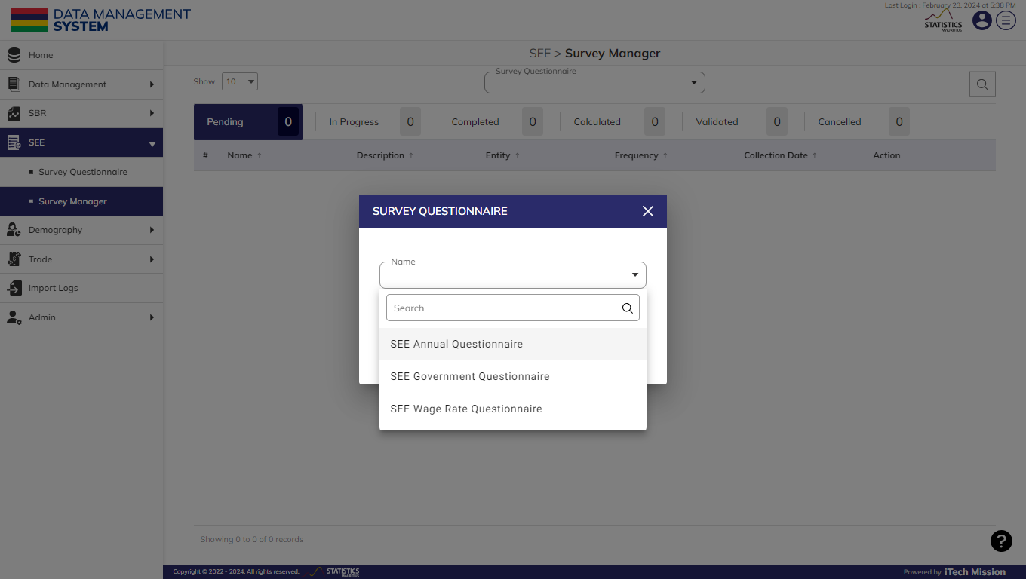Once you have accessed the Survey Manager module, select **“SEE Annual Questionnaire"** from the Survey Questionnaire popup to initiate the data collection process for the selected questionnaire (see below figure).

The first tab view is **Pending**, a new survey when added will be shown under pending tab. You will have the option to setup a new survey cycle (see below figure).

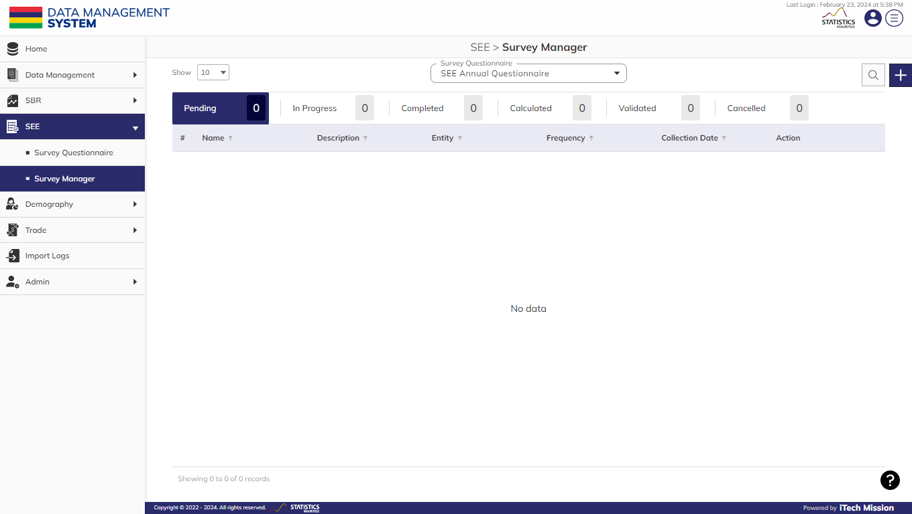Below is the step-by-step guide on how to add a new survey.

**Step 1:** Click on the **Plus** button and enter the following details (All details that are mandatory to be entered)to set up a new Survey Cycle.

* Update **Survey Name**
* Enter survey **Description**
* Enter **From Date**
* Enter **To Date**
* Select **Frequency** *(Annually, Quarterly or Monthly)*
* Select **Year**
* Select **Quarter** *(in case frequency is selected as Quarterly)*
* Select **Month** *(in case frequency is selected as Monthly)*
* Add **Entity**
* View the added **Entity**

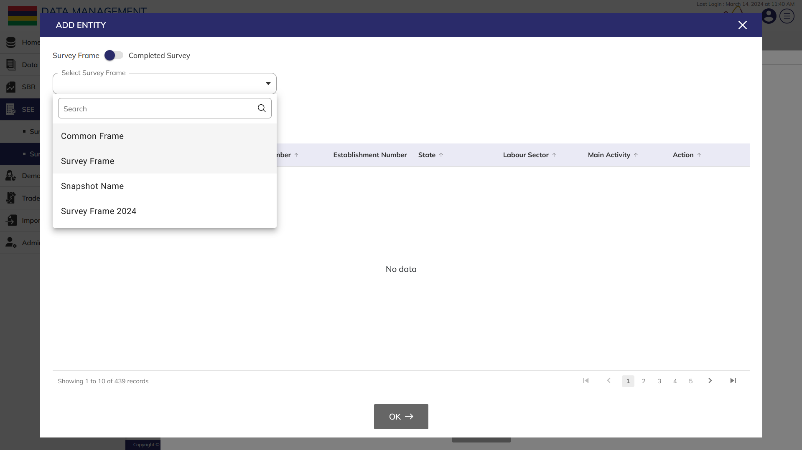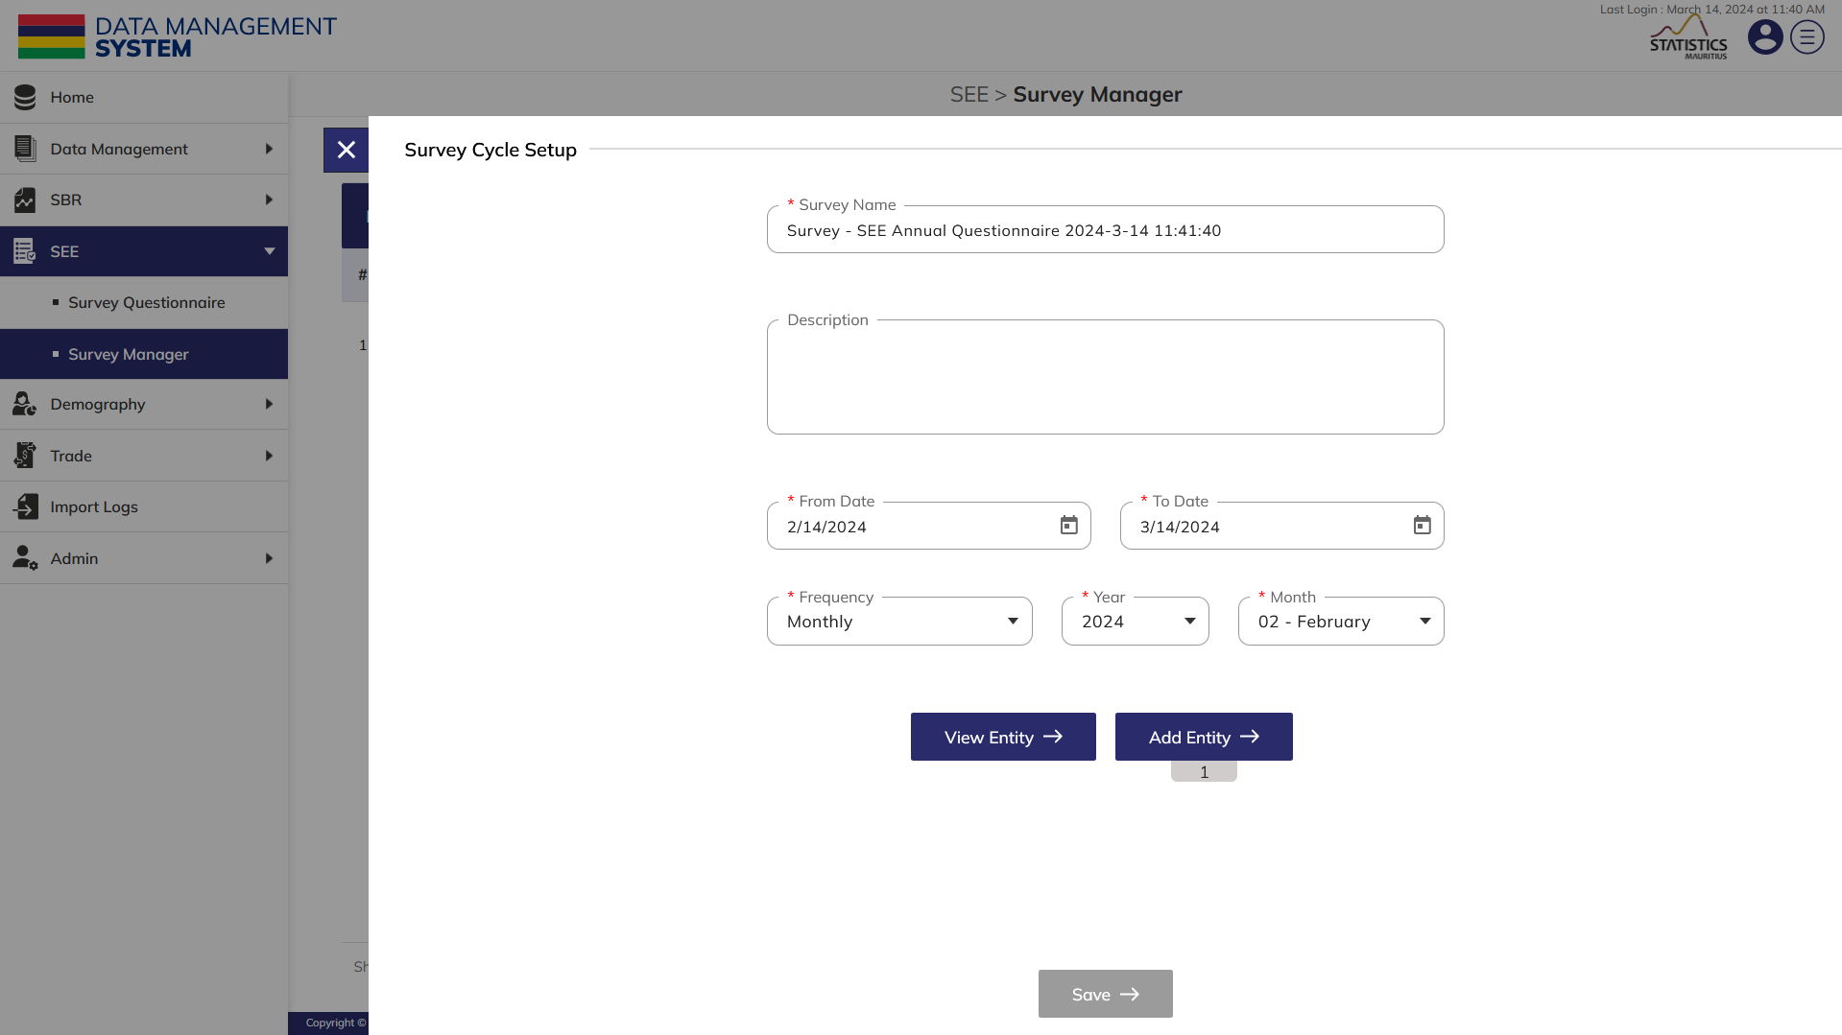**Step 2:** Click on the **Add Entity** button to select establishment(s) where survey data has to be collected. You have the options to select entities from one of the survey frames from the list of the available survey frames (see below figure).

**Step 3:** Click on the toggle option to switch to **Completed Survey.**  **Add Entity** button helps to select establishment(s) where survey data has to be collected. You have the options to select entities from one of the survey frames from the list of the available survey frames (see below figure). Or toggle to switch to completed survey

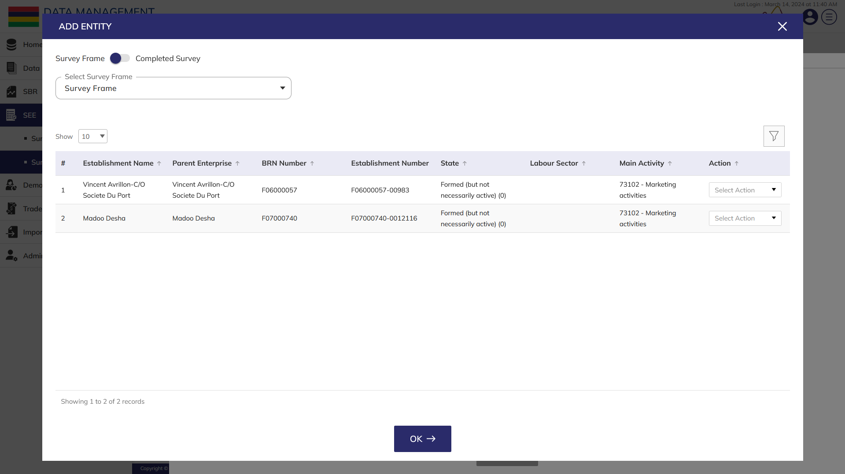**Step 4:** Select **Survey Frame** as “Survey Frame” if survey frame option is selected or Select **Survey Cycle** and **Survey/ Supplementary Frame** if completed survey is selected. The list of establishments(s) available in the selected survey frame will start showing in the tabular grid. You have the options to search, sort, and filter the establishment list (see below figure).

Suppose you want to collect survey data for establishments whose BRN Number is “F06000057”

**Step 5:** Click on the **Filter** option and enter following details to select establishments(s) as per the required filter criteria (see below figure).

* Enter **Filter Name**
* Select Column as “Brn of Parent Enterprise”
* Select Operator as “=”
* 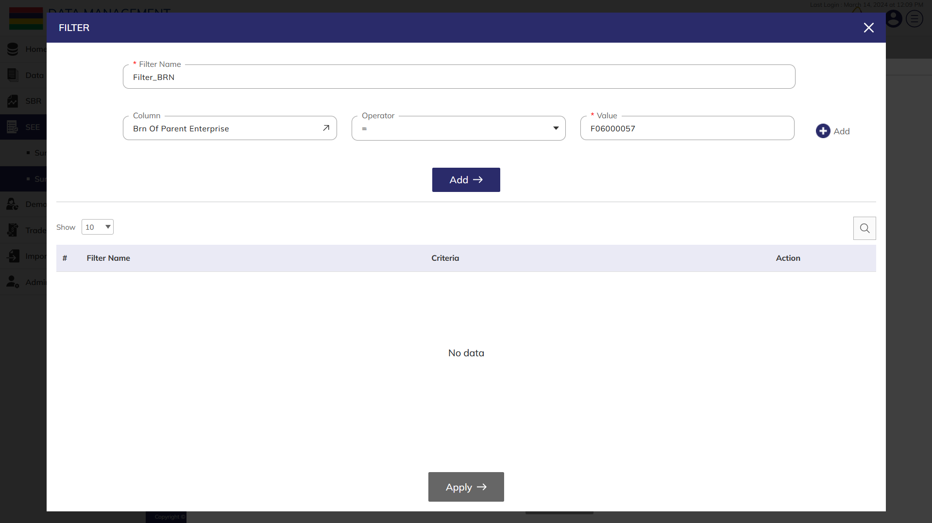Select Value as “F06000057”

**Step 6:** Click on the **Add** button to save the filter and the added filter will start showing in filter list table below. You have the option to **Delete** the added filters in the action column.

**Step 7:** Click on the **Apply** button to apply the saved filter criteria on the establishment list of the selected survey frame.

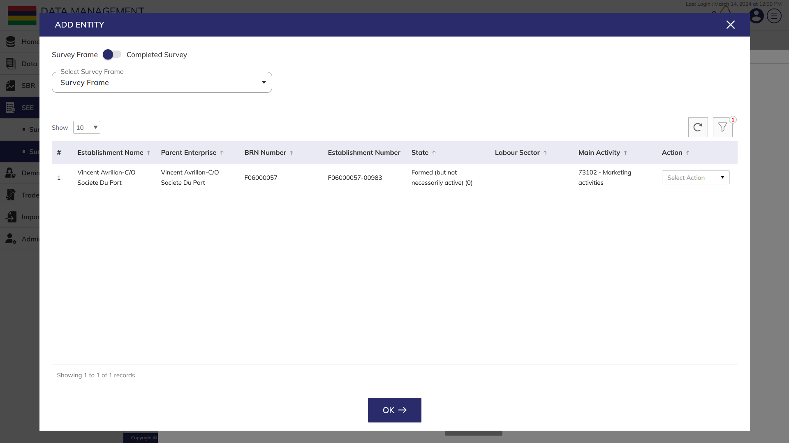Now, the establishment list will be filtered as per the defined filter criteria (see below figure).

**Step 8:** Click on the **OK** button, to confirm assigning the establishment(s) to the survey cycle

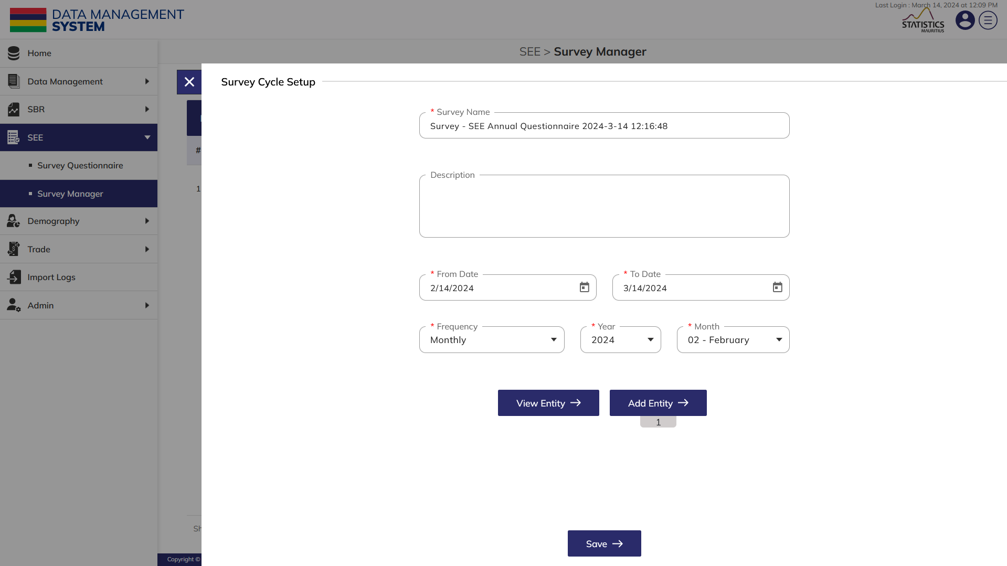**Step 9:** Click on the **View Entity** button, to view the added entity (see below figure).

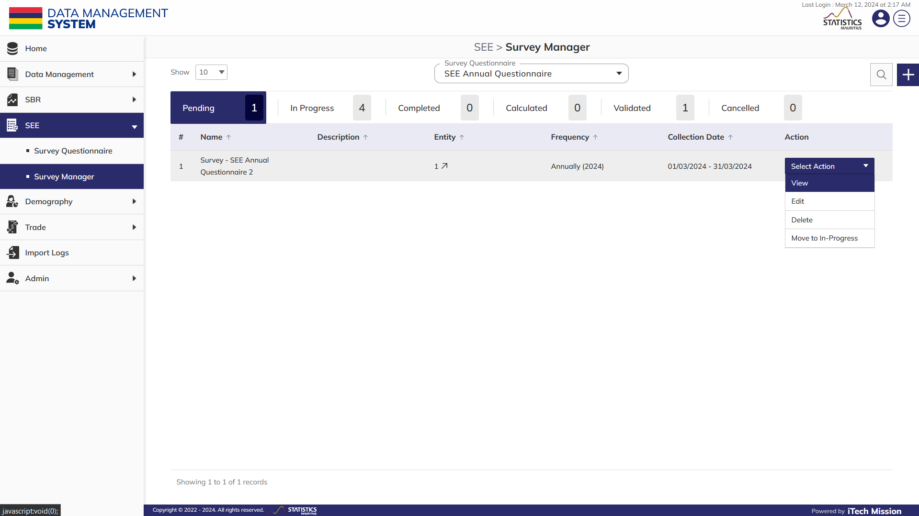**Step 10:** Click on the **Save** button to confirm saving the survey. Now, the survey setup is completed and you can view the created survey in pending tab (see below figure).

**Step 11:** Click on the **Arrow** option available under the entity column to view the list of the selected establishment(s).

**Step 12:** Click to select **View** option available in the action dropdown to view survey setup information and questions associated with selected element.

**Step 13:** Click to select **Edit** option available in the action dropdown to edit the details of the selected element. Edit the required detail and click on update button to save and confirm.

**Step 14:** Click to select **Move to In Progress** option available in the action dropdown to move the survey cycle from Pending to In Progress tab. A confirmation popup will appear, click yes to confirm moving the selected element to in progress tab.

**Step 15:** Click to select **Delete** option available in the action dropdown to delete the selected element. A confirmation popup will appear, click yes to confirm deletion of selected element.

### **2.2.2 In progress**

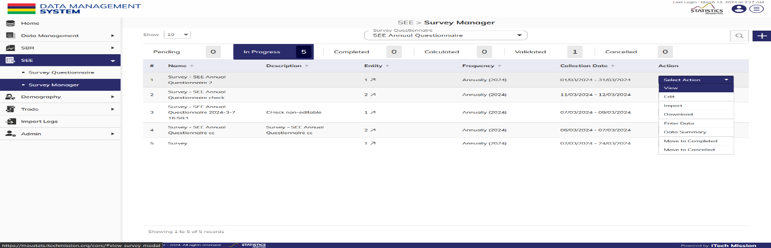After successfully completing the survey cycle setup in the pending tab, the survey cycle moves to **In-progress** tab. The authorized users will be able to perform data entry for the selected survey cycle (see below figure).

Below is the step-by-step guide of the actions that you can perform on the survey cycle available in the In-progress tab view -

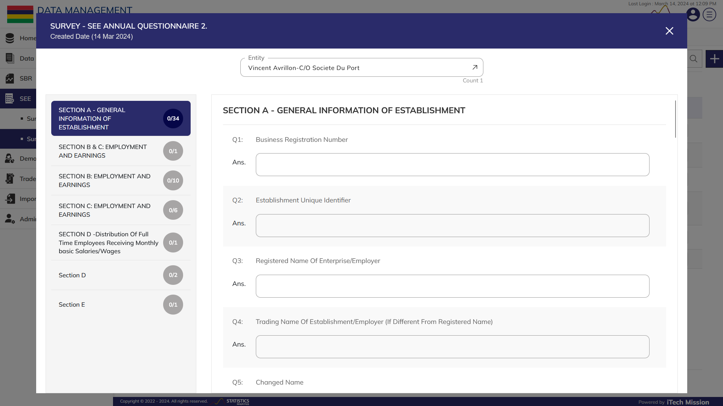**Step 16:** Click to select **View** option available in the action dropdown view the question list by section/subsections including the list of selected establishments in the establishment drop down (see below figure).

**Step 17:** Click to select **Edit** option available in the action dropdown to edit the details of the selected survey cycle. Edit the required detail and click on update button to save and confirm.

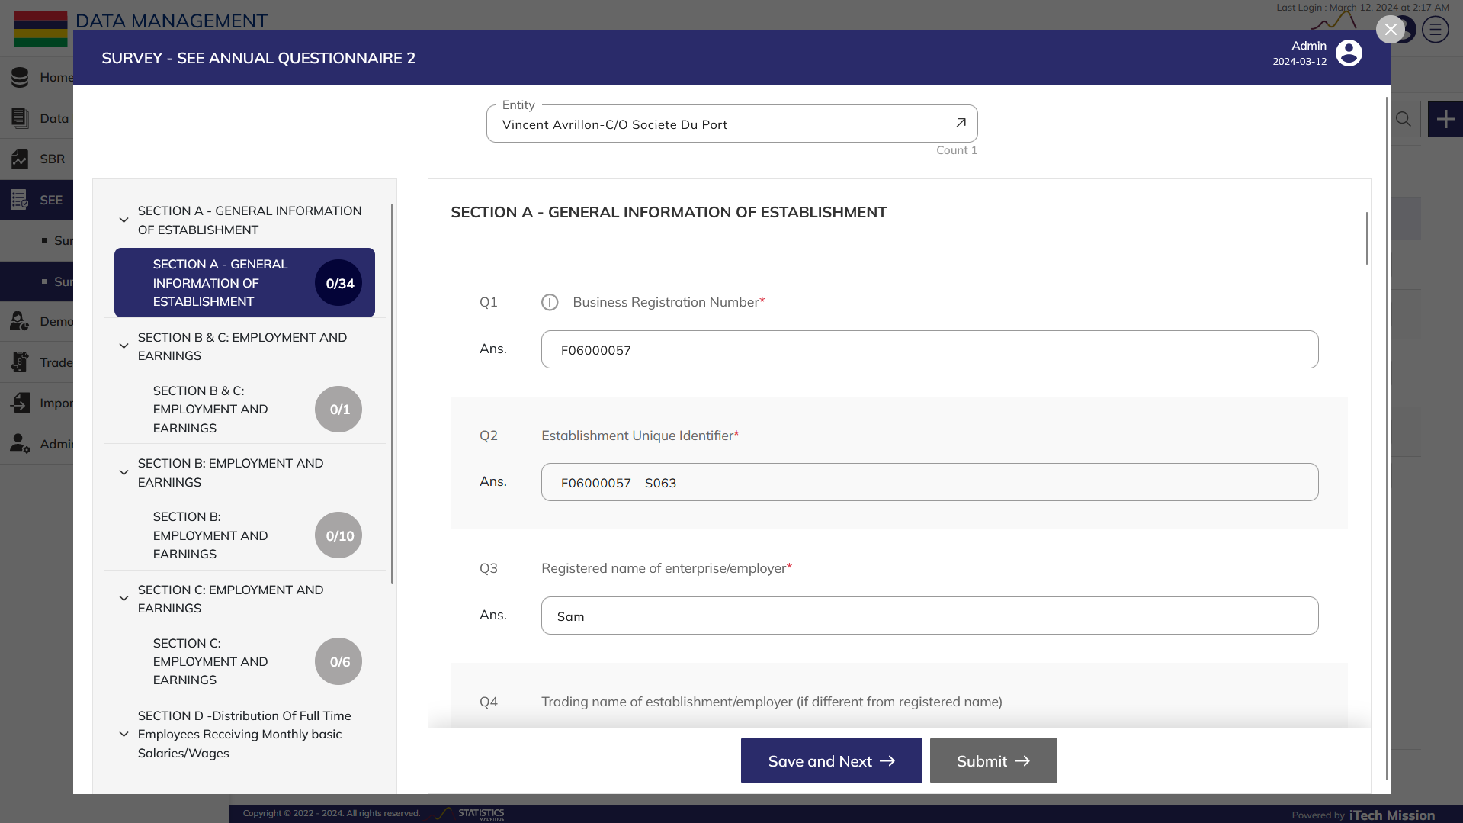**Step 18:** Click to select **Enter Data** option available in the action dropdown. A pop-up window will appear; first you need to select the establishment from the dropdown available to the left above section/subsection navigation. Enter the data of each section. Click on the **Save and Next** button to save the current data and move to the next section. Once the data will be entered for all the mandatory fields, the submit button will get enabled. Click on the submit button to complete the data entry process for the selected establishment.

**Step 19:** Similarly, you have to enter data for each establishment. Click on the cross button to exit the data entry window.

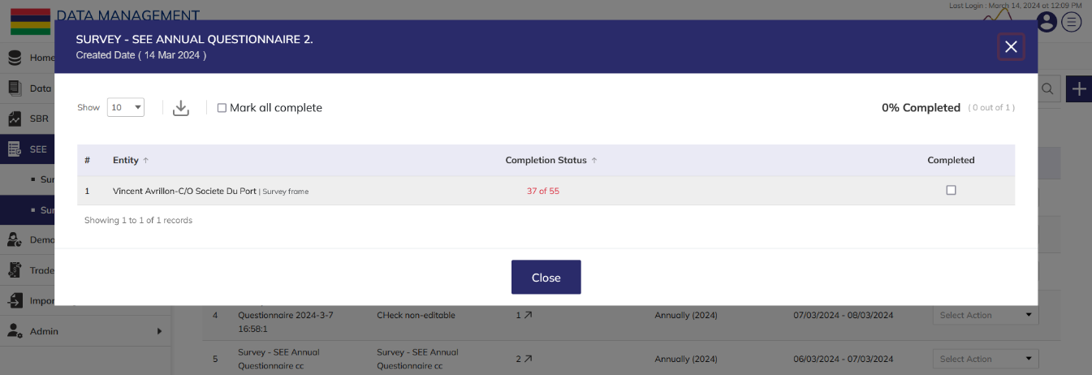**Step 20:** Select **Data Summary** option available in the action dropdown to view the completion status of data entered for all the selected establishment(s) The summary can be downloaded using the download icon. You can also **Mark all complete** by clicking on the checkbox. (see below figure).

**Step 21:** Click to select **Import** option available in the action dropdown to import prefill or carryforward survey data of the selected survey cycle.

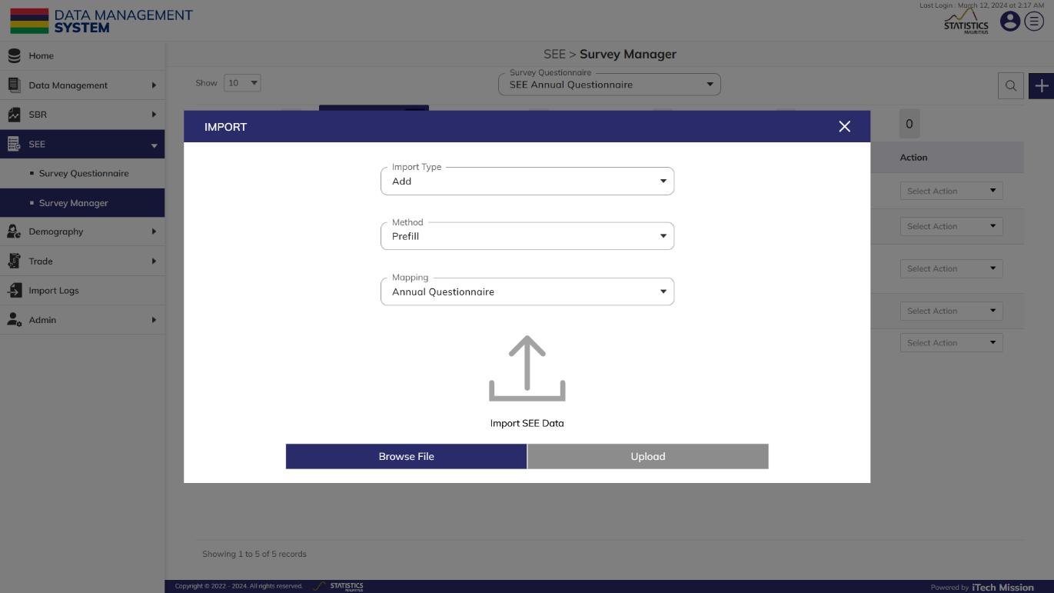To import survey data, select **Import Type**, **Method**, **Mapping** and then click on the **Browse File** button and select survey data file to be imported. Now, click on the **Upload** button to start the import process (see below figure).

During the import process, the records where establishment name is mismatched and associated rules is violated are not imported in the database. A Last Upload summary will appear after the import process which provides the count of successfully imported records out of the total records. An error log will be generated to report on unsuccessful imported records which you can access from **Import Logs** module.

**Step 22:** Click to select **Move to Completed** option available in the action dropdown to move the survey cycle from In Progress to Completed tab. A confirmation popup will appear, click yes to confirm moving the selected element to completed tab.

**Step 23:** Click to select **Move to Cancelled** option available in the action dropdown to move the survey cycle from In Progress to Cancelled tab. A confirmation popup will appear, click yes to confirm moving the selected element to cancelled tab.

### **2.2.3 Completed**

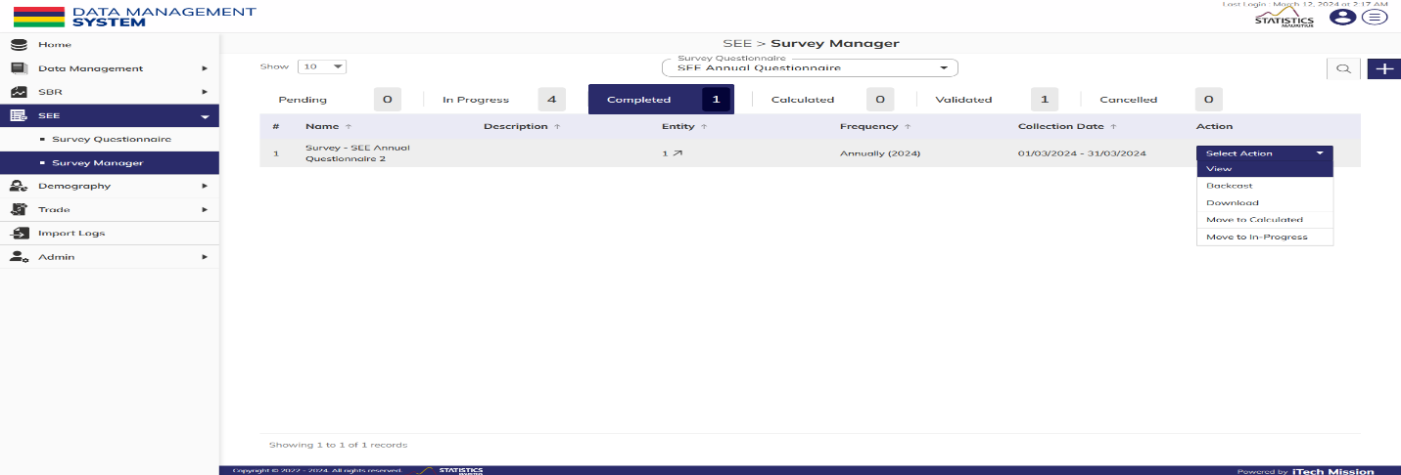After successfully completing the data entry process of survey cycle in the in-progress tab, the survey cycle moves to **Completed** tab. The authorized users will be able to clean and validate the collected data (see below figure).

Below is the step-by-step guide of the actions that you can perform on the survey cycle available in the Completed tab view -

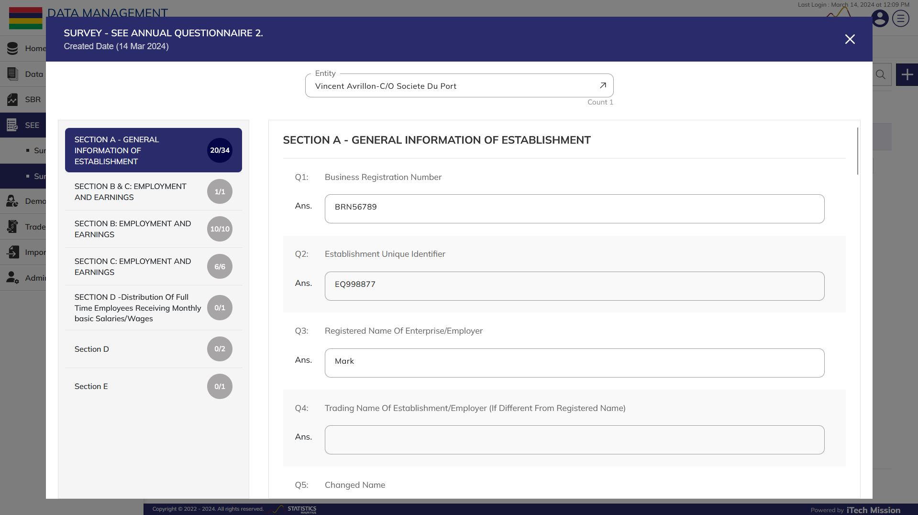**Step 24:** Click to select **View** option available in the action dropdown to view the data entry form by establishments (see below figure)-

**Step 25:** Click to select **Download** option available in the action dropdown to download the data entry form

**Step 26:** Click to select **Move to Validated** option available in the action dropdown to move the survey cycle from Completed to Validated tab. A confirmation popup will appear, click yes to confirm moving the selected element to validated tab.

**Step 27:** Click to select **Move to In Progress** option available in the action dropdown to move the survey cycle from Completed to In Progress tab. A confirmation popup will appear, click yes to confirm moving the selected element to in progress tab.

**Step 28:** Click to select **BackCast** option available in the action dropdown to backcast a survey cycle data to other survey cycle(s).

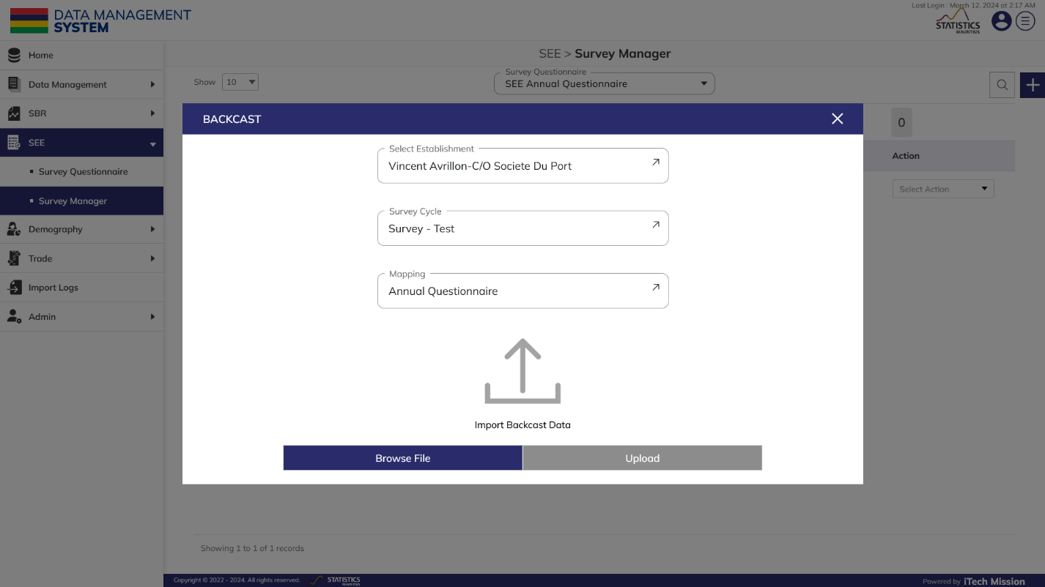To backcast survey data, select **Establishment**, **Survey Cycle**, **Mapping** and then click on the **Browse File** button and select survey data file to be imported. Now, click on the **Upload** button to start the Import process.

During the import process, the records where establishment name is mismatched and rules associated with question in the mapping file is violated are not imported in the database. A Last Upload summary will appear after the import process which provides the count of successfully imported records out of the total records. An error log will be generated to report on unsuccessful imported records which you can access from **Import Logs** module.

### **2.2.4 Calculated**

The survey cycle is successfully moved to **Calculated** tab from Completed Tab (see below figure).

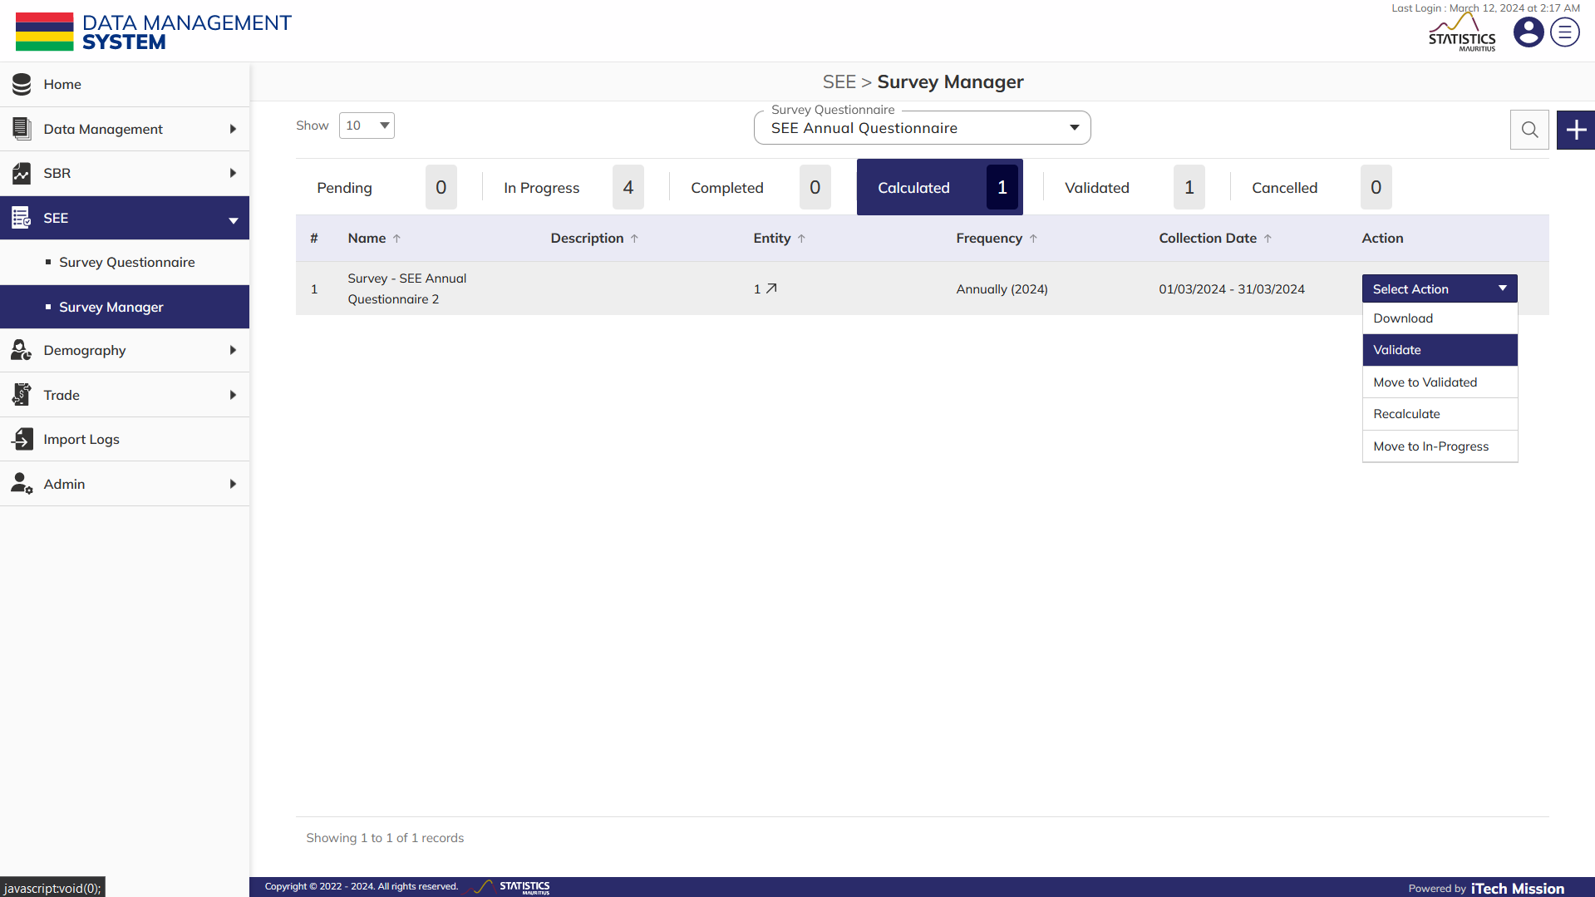Below is the step-by-step guide of the actions that you can perform on the survey cycle available in the Calculated tab –

**Step 29:** Click to select **Download** option available in the action dropdown to download the data. After clicking on download button, a CSV file will be downloaded having the list of questions with their respective responses and calculated data.

**Step 30:** Click to select **Validate** option available in the action dropdown, a pop up window will appear where you will be able to delete, update and validate the responses of the survey(s) collected through data entry process and view the calculated data. (See below figure).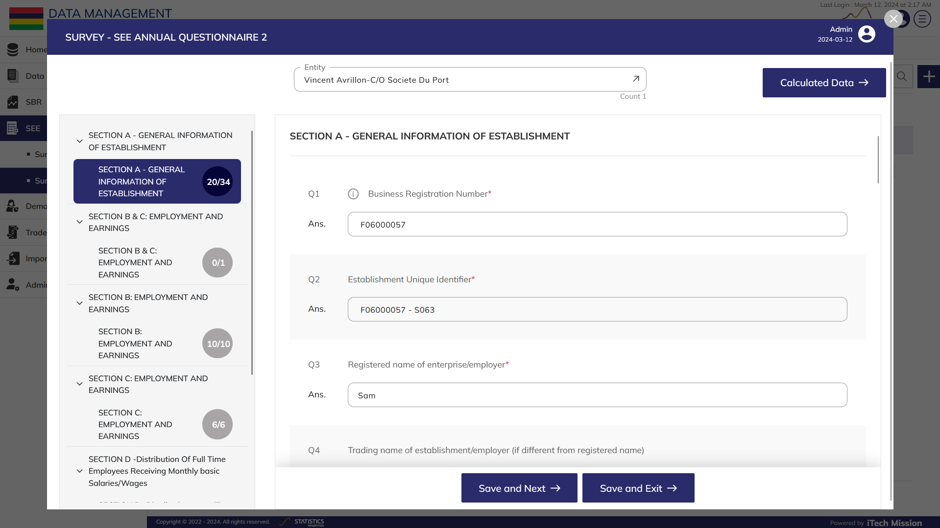

**Step 31:** Click on **Calculated Data** button available at the top right side of the window to view the data which is calculated using formulas that are added in the questionnaire.

**Step 32:** Click on the input box available under sections to update the data entered through data entry process and validate the data. Click on **Save and Next** to move to the next section, once all the updates are done click on **Save and Exit**.

**Step 33:** Click to select **Recalculate** option available in the action dropdown to recalculate as per the updated data.

**Step 34:** Click to select **Move to Validated** option available in the action dropdown to move the survey cycle from Calculated to Validated tab. A confirmation popup will appear, click yes to confirm moving the selected element to validated tab

**Step 35:** Click to select **Move to In Progress** option available in the action dropdown to move the survey cycle from Calculated to In Progress tab. A confirmation popup will appear, click yes to confirm moving the selected element to in progress tab.

### **2.2.5 Validated**

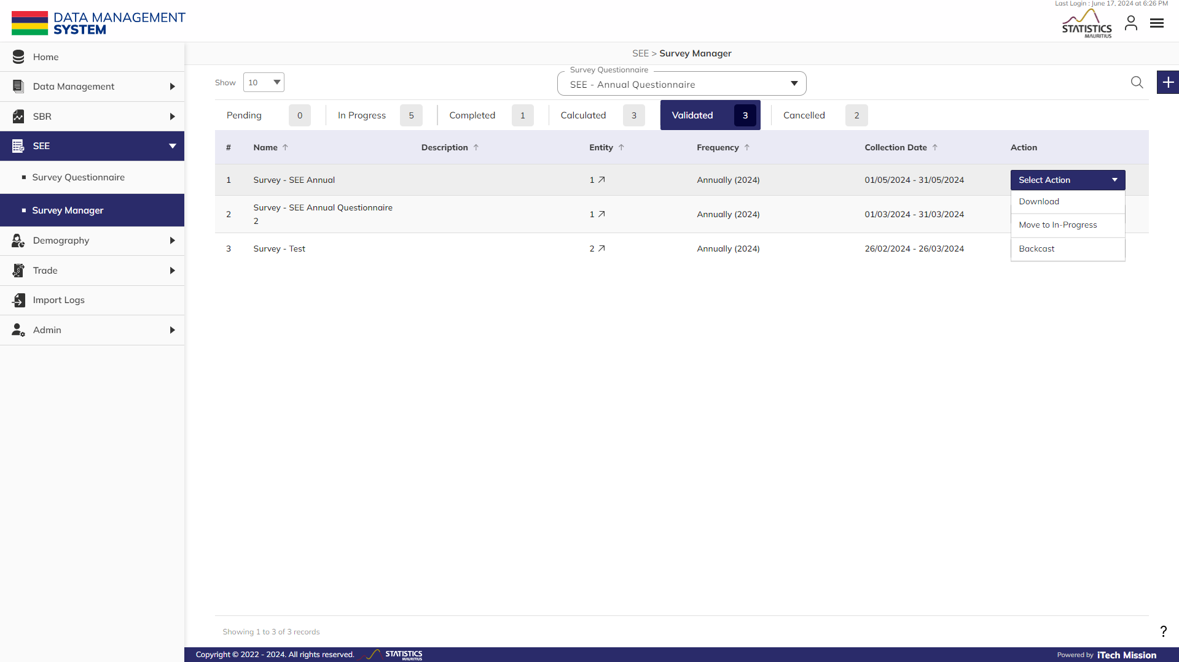The survey cycle is successfully moved to **Validated** tab from Calculated Tab (see below figure).

Below is the step-by-step guide of the actions that you can perform on the survey cycle available in the Validated tab –

**Step 36:** Click to select **Download** option available in the action dropdown to download calculated data. After clicking on download button, a CSV file will be downloaded having the list of questions with their respective responses and calculated data.

**Step 37:** Click to select **Move to In Progress** option available in the action dropdown to move the survey cycle from Validated to In Progress tab. A confirmation popup will appear, click yes to confirm moving the selected element to in progress tab.

**Step 38:** Click to select **BackCast** option available in the action dropdown to backcast a survey cycle data to other survey cycle(s).

### **2.2.6 Cancelled**

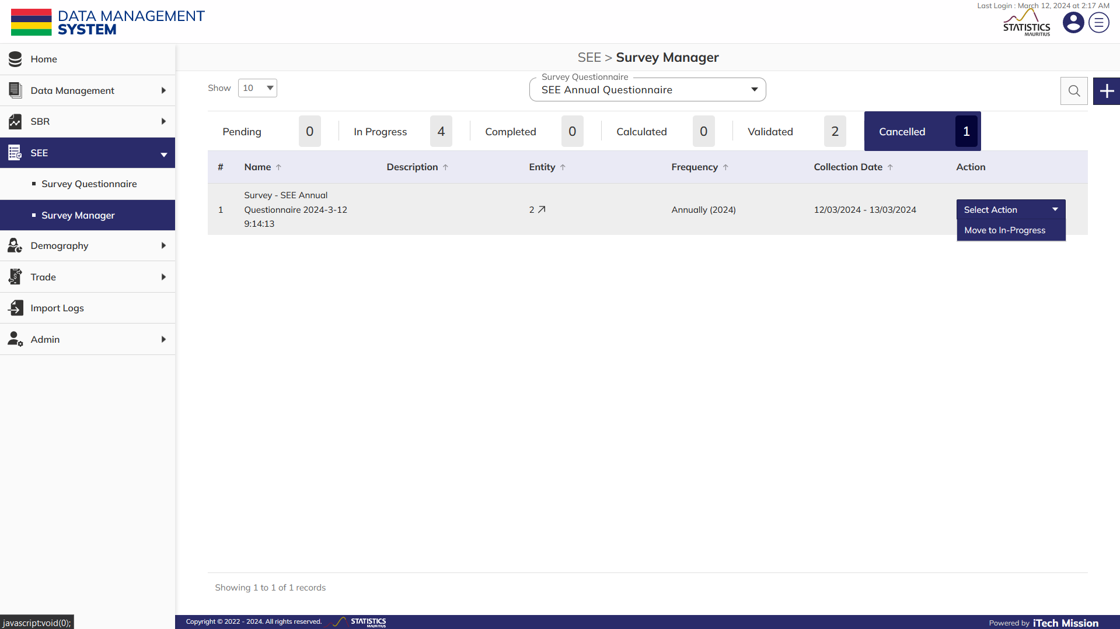All the In-progress survey cycle marked as cancel moves to **Cancelled** tab (see below figure).

Below is the step-by-step guide of the actions that you can perform on the survey cycle available in the Calculated tab –

**Step 39:** Click to select **Move to In Progress** option available in the action dropdown to move the survey cycle from Cancelled to In Progress tab. A confirmation popup will appear, click yes to confirm moving the selected element to in progress tab.



PRODUCT DOCUMENT